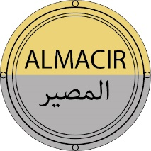
AL-Andalus – MAghreb. CIRculation of gold and silver for coinage in the Medieval Islamic West (8th-13th centuries)

Summary table of persons involved in the project:
The project has one partner: IRAMAT UMR 7065. Staff hired by the project is shown in italics.
Partner | Name | First name | Current position | Role & responsibilities in the project (4 lines max) | Involvement (person.month) throughout the project's total duration
IRAMAT | Gasc | Sébastien | CR CNRS | Coordinator project  Responsible tasks 1 and 5  Co-responsible task 2  Participation to tasks 3 and 4 | 24
IRAMAT | Sarah | Guillaume | CR CNRS | Partner’s scientific leader  Co-responsible task 3  Participation to tasks 2 and 4 | 6
IRAMAT | Blet-Lemarquand | Maryse | IR CNRS | Analytics expertise  Co-responsible task 3  Participation to task 4 | 6
IRAMAT / EPHE | Bompaire | Marc | DR CNRS | Medieval numismatics expertise  Responsible task 4 | 5
IRAMAT | Téreygeol | Florian | DR CNRS | Mines exploitation and archaeological expertise  Participation to task 4 | 5
IRAMAT | Huet | Thomas | IR CNRS | Database expertise  Responsible task 2 | 8
IRAMAT | Phd student |  | To recruit | Islamic numismatics  Participation to tasks 1, 3 and 4 | 36
IRAMAT | Master 2 trainee |  | To recruit | Digital Humanities  Participation to task 2 | 6

Any changes that have been made in the full proposal compared to the pre-proposal / compared to the registration
The recruitment of a research engineer at IRAMAT, specialising in databases, as mentioned in the pre-proposal, opens up prospects for recording the project's results. So, Thomas Huet has joined the ALMACIR project team.

Proposal’s context, positioning and objective(s)

Objectives and research hypothesis
What were the circulation networks for precious metals used in coinage in the Islamic West, from the Arab conquests to the Berber dynasties (8th-13th centuries)? Where did the gold and silver minted by the various States of the Muslim West come from? To what extent did political changes in the Maghreb and al-Andalus influence the circulation of precious metals?
The ALMACIR project focuses on the western part of the Dār al-Islām, between the Arab conquests of the Maġrib al-Aqsā and al-Andalus at the turn of the 7th-8th centuries and the fall of the Almohads in 668/1269. Based on the testimony of written sources, traditional and recent historiography has demonstrated the importance of sub-Saharan gold, and the routes of its circulation transiting through Siǧilmāsa [1]. More recently, archaeological studies in North Africa [2], particularly in Siǧilmāsa area [3] have added a new dimension to these studies. While the circulation of precious metals has tended to focus on gold, the circulation of silver has to be highlighted, especially its possible movement to the Iberian Peninsula from North Africa, where there were renowned mines, such as those in the Moroccan Atlas whose wealth was highlighted by the 9th century geographer Ibn Ḫudāḏbih.
The area was subject to different authorities, with the Maġrib al-Aqsā gradually linked to al-Andalus, with the expansion of the Umayyad Caliphate of Cordoba to the south of the Strait of Gibraltar, until the control of Siǧilmāsa (366/976), and with the conquests and retreat of the Almoravids and then the Almohads in the 12th and 13th centuries. The project is based on an examination of the circulation of gold and silver in these varying political contexts, through a new light: that of the chemical composition characteristics of coins.
The main objectives of ALMACIR are:
1) to assess the circulation of these metals over a broad chronology between sub-Saharan Africa, the Maġrib al-Aqsā and al-Andalus;
2) to quantify the evolution of this circulation;
3) to determine the impact of changes in domination in the region.
Our research hypotheses are the following:
1) The different phases of increase in monetary production, as highlighted by numismatic studies, imply different stocks of metals. It could have come from Iberian mines, as archaeology has partially demonstrated for the Umayyad period [4], or from deposits outside the Peninsula, even outside al-Andalus. Some mints in the Muslim West were able to use metals of common origin.
2) The notable changes in the supply of coinage are the result of and reflect the contacts and influences in the western Mediterranean basin. The exploitation of silver mines in North Africa could have been a source of supply, particularly for the Iberian Peninsula, depending on the areas controlled by the various powers.
3) Political developments and expansions in the Muslim states of the West may have influenced the circulation of precious metals. Umayyad control of Siǧilmāsa, and above all, the Berber conquests of the 12th-13th centuries probably led to the arrival of sub-Saharan gold in al-Andalus, where dinars of renowned quality were minted.
The ALMACIR project proposes a multidisciplinary approach to achieve its objectives. Benefiting from a dense historiography on the subject, the project will be based on the most recent archaeological data on the Saharan zones, on a large-scale numismatic study, considering for the first time the coinage of all the Muslim states of the West between the 8th and 13th centuries, and on archaeometric data, which it proposes to develop to an extent never before envisaged for this coinage.

Position of the project as it relates to the state of the art
The circulation of precious metals in the first centuries of the Hegira has been the subject of great interest among historians. Opposing Henri Pirenne's theory, who saw the Arab conquests as the real cause of the decline in Mediterranean trade [5], Maurice Lombard had sought to demonstrate that the Arab conquests had, on the contrary, revived Mediterranean trade for having enabled a new circulation of gold from the East, after a phase when it had been hoarded and therefore absent in the West [6]. In addition to written sources, each of the two historians drew on archaeological evidence, particularly monetary finds, to support their arguments. Since then, archaeology has often been used to study Mediterranean trade in the early Middle Ages [7]. More specifically, the circulation of metals in the western Mediterranean basin has been the subject of a number of studies, based on written sources, which highlight the importance of sub-Saharan gold in Western coinage [8], which has long been seen as one of the resources enabling the resurgence of gold minting in the West [9]. Indeed, Europe was characterised by silver monometallism for much of the Middle Ages, and the Iberian Peninsula was linked to this same silver area under the Umayyad emirs, until the first caliph of al-Andalus, ‘Abd al-Raḥmān III, resumed the minting of dinars in 316 / 929.
The study of the circulation of coins in the Mediterranean has been used to assess these issues of Mediterranean trade, particularly for the early Middle Ages [10 and 11]. Some studies, more geographically restricted, have helped to shed light on the circulation of Islamic, such as between the Maghreb and the Iberian Peninsula [12]. However, archaeometric data seems to be the most suitable for providing answers to these historical questions. Coins from al-Andalus minted between the 8th and 13th centuries have in the past been the subject of elemental analysis, using a variety of methods, often limited to the surface areas of the coin [13], and whose accuracy and reliability remain unsatisfactory. Moreover, the method does not allow a precise determination of all the elements potentially tracing gold, as allowed, on the contrary, by the Laser ablation inductively coupled plasma mass spectrometry (LA-ICP-MS) method and the proton activation. This latter one has nevertheless already been used for Islamic coins on some studies: as with the eastern regions of the former Umayyad caliphate of Damascus [14], and also, on dinars from the Islamic West [15], coupled with the LA-ICP-MS method analyses. The latter method has also been used to determine the trace elements of early Islamic coinage in the Maghreb [16]. While the samples studied were unfortunately not always sufficiently representative, as the authors of this innovative research sometimes regretted [17], the results obtained bear witness to the relevance of the multi-elemental (major, minor and trace element) analysis for gold coins. Then, since the early 2000s, it is considered that a more exhaustive study would make possible to quantify the proportion of gold from Sudan [18], and, thanks to a broader comparison, to distinguish between gold from the Sudanese and Malian regions in the coinage of the Dār al-Islām. On the other hand, no similar work has ever been done on silver, and the circulation of precious metals, particularly between the African continent and the Iberian Peninsula, has usually been considered independently. However, the importance of North African silver mines has been highlighted, particularly from the Idrisid period onwards (late 8th-10th century) [19]. In a context where the political stakes were decisive for the control of trade routes, combining the study of the two metals seems essential and will provide a general overview of their circulation and help to better understand the dynamics of coinage.
Then, by carrying out LA-ICP-MS analyses on a vast corpus, including gold and silver coins, the project will establish the first extended compositional reference system for dinars and dirhams minted in the West. This will allow to examine differences in gold and silver content and trace element characteristics between mints and periods, in correlation with political and economic developments. The results obtained on dirhams and qīrāt-s will offer a renewed vision of the “silver crisis” (or “silver famine”) in the Dār al-Islām around the 11th century [20 and 21]. On the other hand, compositional analyses will made possible to formulate hypotheses about the supply of mints that struck dinars in the medieval Islamic West. Particular attention will also be paid to the early gold coins of the Christian powers in the Iberian Peninsula, modelled on Islamic coins and with Arabic legends, such as those of the 11th century Catalan counts, known as mancusii [22], or the 12th century dinars struck in the name of the kings of Castille, known in al-Andalus numismatics as maravedís [23].
The project will be able to draw on a number of preliminary results. First of all, the collection of the main partner institute, the BnF, has been consulted, and an initial target figure for analysis can be put forward for the Umayyad period, enabling the analysis phase to begin in the early months of the project.
For gold coins, in addition to some of the pioneering work described above, the project will be able to draw on analyses carried out at IRAMAT on dinars from the Cluny treasure [24].
In addition, initial analyses of the dirhams of the independent emirs of al-Andalus, carried out at IRAMAT in 2024 on 28 dirhams, have already provided initial results showing the major trends in silver supplies (fig. 1), ensuring the relevance of extending the approach to a larger corpus covering a broader chronology.
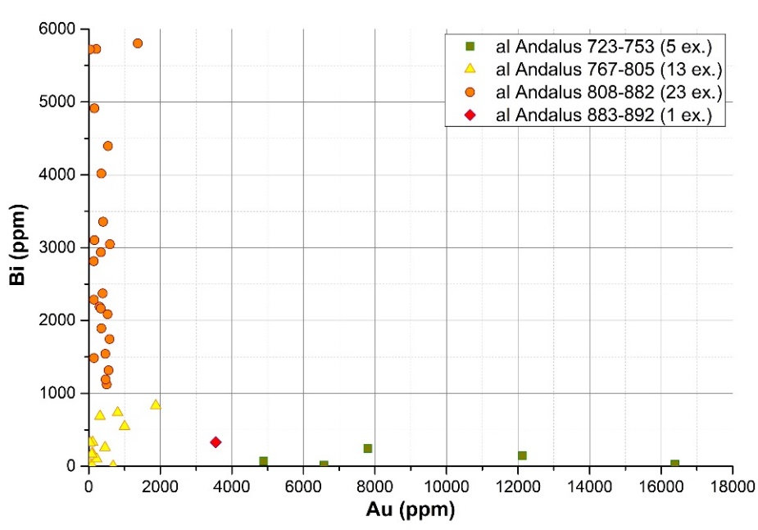
Fig. 1. Concentration of trace elements (gold and bismuth) in dirhams from the Emirate of al-Andalus, using LA-ICP-MS method. Preliminary and unpublished results by S. Gasc and G. Sarah (graphic by G. Sarah).
Then, the ALMACIR fits in with the dynamics of current research on the medieval Islamic West. Using archaeometry, it offers a new and innovative perspective. Another innovative aspect of the project is the inclusion in the corpus of coins from archaeological sites. As well as providing a better understanding of the uses of coins, this approach will broaden the scope of the corpus, whereas chemical analyses have most often been devoted to coins in large museum collections and, in some cases, to monetary treasures.
Then, the focus is on the analysis of over 220 gold coins (dinars) and almost 550 silver coins (dirhams and qīrāt-s) minted by the Islamic States established in the western Mediterranean from the early 8th century to the 13th century. These analyses will be carried out using LA-ICP-MS, a non-destructive method of elemental characterisation pioneered by IRAMAT for its application to metal analysis [25 and 26].

Methodology and risk management
ALMACIR is scheduled to last 48 months. Focusing on the western Mediterranean areas, the project will analyse coins from several mints in the region (fig. 2). Most of these mints are represented in the BnF collection, providing an almost exhaustive overview from the outset of the project.
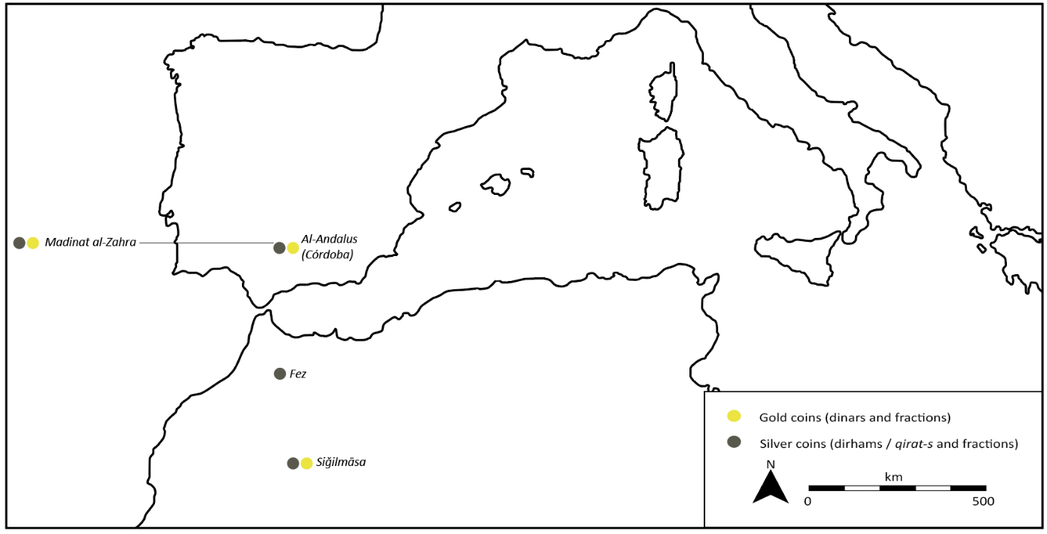
Fig. 2. Mints represented in the projected corpus
This project is organized in 5 tasks, from the numismatic study of the collections to the publication of the results. In fact, at various steps of the project, publications will be submitted to international journals in the various fields covered, history, archaeology or archaeometry. These renderings are presented in the following tasks.

TASK 1. Cataloguing gold and silver coins available for analysis (8th-13th c.)
Responsible: Sébastien Gasc
The study of coins from the collections that will provide the coins to be analysed will allow to retrace the monetary history of the reigning and issuing dynasties in the western Mediterranean basin. Compatible with and complementary to the coordinator's research programme, this first part is already underway and will be continued even before the project begins.
Task 1.1. Numismatic studies
Objectives. The aim will be to gather in a single corpus all the coins likely to be the subject of elemental analyses. Many of the coins studied were minted in al-Andalus, but the other areas of the Muslim West are also well represented in the corpus.
Methods. This task will be based on the study of several collections, some of which are already known to the project coordinator. In a second phase, the corpus of coins to be analysed will be defined on the basis of the characteristics of each, in particular the years and mints of issue. While the dinars and dirhams of al-Andalus are well known and listed in numismatic catalogues, no recent approach has provided an overview, brought together in a corpus the coins of the various powers of the Muslim West.
In view of the amount of work involved, the task will be completed as soon as possible, incorporating the coins of the Umayyads, Aghlabids, Idrissids, Midrar dynasty in Siǧilmāsa, Amirids, the various Taifa kings of the 11th century, the Almoravids and the Almohads. These coins will be supplemented by other pieces, which are essential for comparative studies and sometimes complete the chronology or area under consideration. So, the corpus will include the first Christian coins minted after the conquests of the principalities in the north of the Peninsula, based on the Almoravid dinars. The kings of Castile, Alfonso VII (1126-1157) and Alfonso VIII (1158-1214), followed the Islamic model for minting gold. Indeed, the so-called ‘Alfonsín’ dinars (maravedís) imitated the renowned Almoravid coins and were stamped with Christian legends written in Arabic. Finally, several Fatimid dinars minted in the caliphate's western area, in North Afria (as in al-Manṣūriya or in al-Mahdiya) and in Sicilia, will also be studied.
This task will be carried out throughout the project, following on from the coordinator's studies, whose data already allow an initial quantification of coins to analyse (fig. 3). As opportunities for collaboration multiply following the contacts established as part of this application, this phase of the project may be extended over time, although the aim remains to limit it to the first 30 months of the programme.
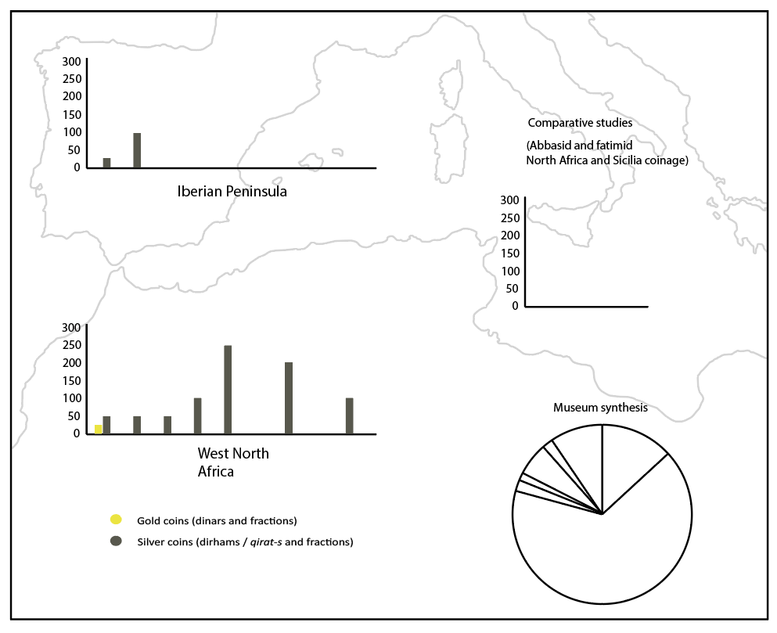Figure 3. Projected corpus
Main participants. This part of the project can only be carried out by numismatists specialist of the coinage of the medieval Islamic West. It will therefore be up to Sébastien Gasc to gather information on the coins and to contact the various institutions likely to be able to provide it. Once the doctoral contract has been awarded, the doctoral student, specialising in Arab-Andalusian coins from the 11th-13th centuries, will take part in this first stage of the project. His or her thesis will be supervised by one of the team members (Marc Bompaire, Professor Emeritus, or Guillaume Sarah, qualified to supervise PhD students) and co-supervised by Sébastien Gasc.
During this phase, the project team will be able to count on the collaboration of staff from the partner museums. First and foremost, we should mention the support given to the project by Cécile Colonna, Director of the département des Monnaies, médailles et antiques at the Bibliothèque nationale de France, and Paul Froment, Acting Curator of Foreign Coins (which includes medieval Arabic coins). In addition, an agreement in principle for access to the coins and their analysis by LA-ICP-MS has been reached with the museums of Castres (France) and Huesca (Spain). A number of meetings has been planned before the conception of the project, as with the Museu Nacional d’Art de Catalunya in Barcelona with which a possible agreement is being studied. The staff of these museums would also take part in the project.
Task 1.2. Coins from archaeological excavations
Objectives. The desire to include coins discovered in archaeological contexts in the corpus will take shape thanks to the contribution of several museums. The Huesca Museum, where fragments of dirhams from the Zaragoza Hudid taifa are kept, originating from an Aragonese site where the excavation campaigns were directed by this project coordinator. Moreover, some findings in South of France could be integrated to the corpus.
Methods. Although they represent only a small part of the corpus, these coins will be the focus of particular attention, and the study will include a careful analysis of the stratigraphic contexts of the finds. Based on excavation reports, and thanks to the relationship maintained by Sébastien Gasc with a number of institutions and archaeologists specialising in al-Andalus and the Maghreb, a number of finds in stratigraphic context could indeed complete the corpus. As well as providing access to coins that are less attractive to collectors than those kept in museums, but essential to an exhaustive approach to the use of coins, such as the 11th-century dirham fragments, this phase of the work will create a perfect example of collaboration around archaeomaterials.
From the outset of the project, in-depth research will be carried out at the main sites, mainly in Spain. Several of these sites are already known to the co-ordinator, particularly in Aragon, such as the medallion cabinet at the Ayuntamiento in Zaragoza, which contains several silver coins minted in the North of al-Andalus.
This part of task 2 is therefore divided into three main areas. The first is to draw up a catalogue of coins from archaeological sites, part of the work already begun and which will be continued in the first few months of the project. Secondly, a collaboration with the archaeologists and museums of the provincial capitals, where the archaeological finds are stored under Spanish law, will be considered to subject this numismatic material to LA-ICP-MS analysis. The same approach has already made possible to include to the corpus the dirham fragments discovered at the Marcén site (Las Sillas, Aragon). Finally, the coins analysed will be added to the database (task 2), along with a description of the stratigraphic context of the find. This will be carefully studied, in consultation with the excavation report.
Main participants. Most of the work will be carried out collectively. In addition to the participation of archaeologists specialising in al-Andalus, some of whom could be invited to take part in the seminar and international colloquium at the end of the project (tasks 4 and 5), the predominance of 11th-century dirhams and fragments in the provisional corpus of archaeological finds will justify the active participation of the doctoral student in this phase of the work, if the theme proposed for doctoral funding is maintained with a focus on the 11th-13th centuries. In addition to this involvement, the presence of archaeologists Sébastien Gasc and Florian Téreygeol in the project will ensure an informed reading of the stratigraphic contexts.
Deliverables of the task 1. A project to publish the coins of al-Andalus held by the BnF was initiated by Spanish numismatists in the 2000s, but appears to have been abandoned. Its resumption would provide an opportunity for a global publication, or partial ones in the form of additions to the catalogues drawn up by Henri Lavoix at the end of the 20th century, especially the one dedicated to al-Andalus [27]. Whatever form it takes, this first deliverable (D1) will allow collections to be published even before the database is put online (task 2).
Risk management of the task 1. The agreement between the IRAMAT laboratory and the BnF, the rich collection conserved in Paris and the knowledge already acquired for the highest periods of the project greatly limit the risk that the project objectives will not be achieved. In addition, the support of other museums, confirmed before the project was submitted, will ensure the constitution of an extensive corpus covering the 8th to 13th centuries. Each of the periods studied will be sufficiently representative.

TASK 2. Creating and feeding the database
Responsible: Thomas Huet and Sébastien Gasc
The coins will then be recorded in a database, specially created in collaboration with a research engineer recruited in February 2025, Thomas Huet, responsible for setting up the database and ensuring the interoperability and reusability of data.
Task 2.1. Creating the database
Objectives. In compliance with ANR directives, which require that the data recorded be accessible and meet interoperability requirements, the database will act as a persistent repository for numismatic data, hosting both archaeological (historic cultural context, dating, etc.) and archaeometric (physicochemical analysis, etc.) information.
Methods. The database will serve as a persistent repository for numismatic data and will be hosted online, enabling various contributors to input data. Descriptive vocabularies of coins will be aligned with Nomisma concepts (thesauri and ontologies) [28]. Nomisma is currently regarded as a prime example of LOUD (Linked Open Usable Data; an extension of LOD) technology in archaeology with, among others, a SPARQL endpoint. We will create and submit any missing concepts in Nomisma, as well as translations of existing concepts from English to French and Arabic.
We plan to use PostgreSQL, a Database Management System, along with its spatial extension, PostGIS. The implementation is anticipated on Huma-Num servers, in conjunction with the developing Postgres database of the IRAMAT laboratory designed to collect all physicochemical data produced by the laboratory (the ANAMAT database, working title). The hosting of ALMACIR alongside with the ANAMAT database will facilitate the sharing of common reference data (such as datatypes) and common workflows (such as data validation), ensuring data interoperability at the laboratory scale. Regular backups of the database will be made to ensure its safety.
Similarly, historical periods and subperiods used for the project will be sourced from the PeriodO time-space gazetteer [29]. When higher granularity is needed or entries are missing, new entries will be created in this gazetteer.
Standardized physicochemical quantifications, along with the use of Nomisma concepts and PeriodO periods, will enhance the large-scale reusability of the data.
Python programming, currently being developed at IRAMAT for both numismatic and physicochemical results, will be used to create dynamic and interactive dashboards hosting descriptive statistics from the database (for example, through Leaflet maps and Plotly diagrams), along with data-driven documents, as well as in raw formats (for example, CSV) and to publish reference data (such as Nomisma-specific classes). Additionally, a plugin currently under development at IRAMAT will allow on-the-fly dumping of searches from the database to the IRAMAT Zenodo community (https://zenodo.org/communities/iramat) and will also be used to publish curated datasets adhering to the FAIR principles, including "how-to-cite," DOIs, and metadata interoperability through the OAI-PMH (Open Archives Initiative – Protocol for Metadata Harvesting).
The ALMACIR project will establish a dedicated GitHub repository under the GitHub IRAMAT organisation (to be created) to host reference data and manage the versioning of Python code specifically developed for the project.
All these developments will enhance the FAIRability of the data and the publication of data papers.
Main participants. Thomas Huet will be responsible for the technical set-up of the database, with scientific support from Sébastien Gasc. The construction of the database will also be of particular importance in the collective thinking of the IRAMAT laboratory, which is keen to build a common database covering all the periods covered by the laboratory's researchers. In addition to the members of the ALMACIR project team, the reflective phase will be open to general discussion within the laboratory.
Task 2.2. Completing the database and insure its interoperability
Objectives. The aim of this task will be to keep the database up to date, and to facilitate the entry of numismatic, archaeometry results and archaeological data by all members of the team. It will also involve ensuring the database's sustainability beyond the ALMACIR project.
Methods. Once the database has been built, the corpus will be added from the current provisional files. Each entry will be accompanied by a numismatic description of the coin with high-definition photographs. These images will be hosted online and delivered through a IIIF (International Image Interoperability Framework, ISO 21127:2019) server in read mode. Throughout the project's lifespan, we also aim to develop an IIIF annotation framework that will enable numismatic specialists to share JSON (JavaScript Object Notation) annotations on the same object collaboratively. This is particularly relevant to spatialise semantic content (ex: palaeographical observations) but also physicochemical analytic samples. This IIIF development will be conducted in collaboration with the Département des Monnaies, médailles et antiques (DMMA) of the BnF, which has extensive experience in IIIF development for numismatics.
This collaboration is also part of BnF's policy of digitising its collections. The recording of very high-definition pictures of each of the coins in the ALMACIR database, and the interoperability of this latter, will enable us to play a full part in the preparation of online access to the collections.
By integrating iconography with formal textual descriptions based on current standards, with annotated region of the image, we will also create a ready-to-use learning base for future automated coin identification through artificial intelligence (AI) and machine learning (ML), using large language models (LLM) for textual analysis and computer vision (CV) for iconographic analysis. Exploratory AI/ML development will be conducted in collaboration with the Huma-Num consortium Pictoria and will pave the way for subsequent research projects following ALMACIR.
The Task 2 involves recruiting a Master's student with a degree in Human and Social Sciences, specialising in digital humanities. This student will have to maintain the GitHub repository set up in the task 2.1 and ensure the database's interoperability with partners during his/her six-month placement.
Main participants. All project participants will have access to the database. Sébastien Gasc and the doctoral student recruited as part of the project will be responsible for filling in the numismatic records. The results of the analyses will be completed as the project progress, in particular by Guillaume Sarah and Maryse Blet-Lemarquand (responsible for task 3). Finally, the database represents a critical component in training the Master's student, immersing him/her in the vast realms of digital humanities, IT, FAIR practices, and Open Science.
Deliverables of task 2. The main outcome of the task is, of course, the database (D2). The reflection on its construction will also be part of a collective approach, shared by all members of the laboratory, ensuring continuity in the database well beyond the project.
Risk management of task 2. Although creating a database and opening it up, with a view to interoperability, represents several scientific and technical challenges, the risk of failure of this task can be considered zero.

TASK 3. Elemental and isotopic analyses
Responsible: Maryse Blet-Lemarquand and Guillaume Sarah
The analyses of the gold and silver coins will be carried out following the progress made in task 1 and the results will be recorded in the database (task 2). Preliminary progress on these first two tasks will enable analyses to be initiated at the start of the project.
Task 3.1. LA-ICP-MS Analysis of coins
Objectives. The central task of the project will be to determine the composition of the alloys used in the dinars and dirhams of the Muslim West and to reveal the trace elements.
Methods. Each selected coin from the corpus will be analysed in the IRAMAT. The coins will be transported from their place of conservation to the laboratory where they will be photographed and then analysed by LA-ICP-MS, a method developed for gold and silver coins in the early 2000s.
This analysis method enables the main constituent elements of gold (gold, silver, copper), silver (silver, copper) and copper (tin, zinc, lead) alloys to be measured down to the ppm level (parts per million), as well as most of the impurities present in these metals, up to 30 elements. It also has the advantage of being virtually non-destructive, eliminating surface enrichment (a problem encountered mainly with silver coins, and to a lesser extent with gold coins) and allowing a high rate of analysis. No sample preparation is required, and objects can be returned immediately after analysis.
During the analysis, the coins are placed in a cell called an ablation cell. A laser beam is used to take a micro-sample, with an impact diameter of between 0.02 and 0.08 millimetres and a depth of usually between 0.1 and 0.4 millimetres, making it invisible to the naked eye. The sampled material is transported to a plasma torch in a gas stream, where it is dissociated and ionised. The various constituents are identified according to their mass-to-charge ratio; a computerised system recovers the data and calculates the composition of the coins. Each coin is generally analysed 3 times.
The method will make it possible to analyse 15 currencies per working day, dinars or dirhams. In view of the projected corpus, approximately 11 weeks should be allowed for the study of the entire corpus. This laboratory work will be carried out throughout the project, grouping the coins by period and progressing according to the chronology of the project.
Particular attention will be paid to the content of trace elements known as ‘platinoids’, which can be used to distinguish gold stocks of different origins [30] and of impurities of silver (gold and bismuth, see fig. 1) that can be used to trace silver stocks [31].
Main participants. The LA-ICP-MS analyses will be carried out at the Centre Ernest Babelon in Orléans, by members of the project team. Under the scientific co-ordination of Guillaume Sarah for silver and Maryse Blet-Lemarquand for gold, the analyses will also be carried out by Sébastien Gasc and the contract PhD student recruited for the project.
Task 3.2. Lead isotope analysis of dirhams
Objectives. The aim will be to determine the origin of the silver used in the minting of dirhams through the determination of the isotopic ratios of lead. These coins, which are very well represented in the corpus, will provide a valuable reference that can be compared with data already collected on mines in the Mediterranean basin.
Methods. This part of the task will only concern dirhams whose alloys contain enough lead to provide reliable results. In addition, the issues raised by the project and the data already available on lead isotopes justify restricting the approach to silver in order to identify the regions that produced the metal used in coinage in the Islamic West although recent work has highlighted the possibility of extending isotopic analysis to elements other than lead, in particular iron and copper for dinars [32]. As such analyses cannot be carried out at IRAMAT, the ALMACIR project will call on a service provider, in accordance with the project budget. It as has been done in the past with subcontracting to the BRGM (Service géologique national), and could be carried out in the context of this project by the SARM (Service d’Analyse des roches et des minéraux, CNRS, UMR 7358).
The method will initially involve selecting around 100 dirhams, already analysed by LA-ICP-MS, according to the results of chemical analyses, their date of issue and their mint. Despite the reduced damage caused to the coins by isotopic analysis [33], it may not be possible to select the entire corpus from museum collections. The project could then finance the acquisition of several dated fragments for isotopic analysis.
Once the dirhams have been selected, they will be transported to the subcontracting laboratory and subjected to isotopic analysis. The method consists of taking a sample which is then immersed in a solution to measure the different isotopes of one of its elements, in this case lead. The results indicate the geological age of the mineralisation, which can reveal the place of exploitation.
The method is therefore complementary to analyses by LA-ICP-MS [34] and will allow to clarify the hypotheses developed through chemical analyses.
Main participants. The project team will have to select the dirhams for which the expected results will be the most revealing. Collaboration between specialists in numismatics and archaeometry will ensure consistency in choices. Analyses will be conducted by a service provider whose identity will be determined at the start of the project, giving preference to the SARM whose rates are those anticipated in the project budget.
Deliverables of task 3. The main output of this task will be the publication of the results of chemical analyses, considered by periods (D3). The specialities of the team members will also allow for publication on the description of the analytical method used, and its relevance in the application to coins, which will be proposed to an archaeometry journal (D4).
Risk management of task 3. The main risk therefore concerns isotopic analyses. The damage caused by this method is reduced but greater than that caused by LA-ICP-MS analyses, making it more difficult to obtain authorisation to take such samples. This may limit the number of coins subjected to these analyses. This risk has been taken into account, and the project proposes only a small proportion of isotopic analyses, carried out on a strict selection of coins.
The possibility of acquiring fragments of dirhams, especially for this study, further limits the risk.

TASK 4. Survey and synthesis of analysis data
Responsible: Marc Bompaire and Sébastien Gasc
The numismatic and archaeometric study will be compared with data from written and archaeological sources. This task will therefore provide an opportunity to set up a network of researchers from different specialities. To give concrete form to this joint work, the progress of the study will be regularly presented at a seminar organised in Orléans and Paris.
Task 4.1. Comparative data with written and archaeological sources
Objectives. The objective of this task will be to include the work carried out in the historiography of the subject. Thanks to the project’s interdisciplinary approach, the comparative data will be done collaboratively.
Methods. The first step of the task will concern the data from written sources, already largely listed in the historiography. The method will nevertheless require a rereading of the Arabic sources, in light of the data collected by the ALMACIR project. A great attention will therefore be paid to mentions in Arab sources of trans-Saharan trade and the wealth of African mines, whether for gold or silver. Latin sources will also be the subject of a meticulous study to collect exhaustive references to African gold.
As archaeological work in North Africa has expanded in recent years, the latest results of excavations in the Maghreb, particularly in Morocco and the Siǧilmāsa region, will help to inform the thinking behind the project and will be essential for interpreting the results. The second step of this task will therefore focus on the collection of archaeological data, enabling collaboration with archaeologists specialising in the region (tasks 4.2 and 5.2).
All these data will be compared with those from the project's main source, currency. The numismatic work will bring all the more clarity to the results as the numismatics of al-Andalus have enjoyed a remarkable dynamism since the early 2000s. North African coin issues have also benefited from a certain amount of work in recent years, although this has only resulted in partial publications. Access to unpublished theses, or to publications from collections currently in press, will help to achieve the aim of the project, which is to study all the coins of the Islamic West.
Main participants. The complementary scientific profiles of the team will enable this comparative phase to be tackled fairly early in the project timetable. While certain stages can be initiated upstream, such as updating the bibliography on the subject, the comparative study can be carried out as soon as the first results are obtained. Then, Sébastien Gasc will be working on Arab, numismatic and archaeological sources, Marc Bompaire on numismatics and Latin sources, Florian Téreygeol on archaeological sources and the comparison of data with mining archaeology, especially mining archaeology, and the doctoral student on numismatic and archaeological sources. The updating of references concerning archaeometric methods and results will be ensured by Maryse Blet-Lemarquand and Guillaume Sarah.
Task 4.2. Collaborative reflection
Objectives. This task will involve pooling thoughts, taking advantage of the complementary profiles of the team members. In this way, they will be helped by the participation of other researchers in a seminar specially organized during two of the four years of the project.
Methods. The method will be based on regular working meetings, organised each month, for the members of the team. Each of these meetings will be an opportunity to comment the progress of the project, in the form of a report. As most of the team members work on a daily basis at IRAMAT's Ernest Babelon Centre in Orléans, exchanges will be facilitated, but the monthly meetings will aim to bring together all the members, including those attached to the laboratory's other sites. A number of these meetings will be held by a video-conferencing system, in order to reduce travelling time and funds requested.
Above all, this task will be based on the organisation of a 12 sessions seminar during the second and third year of the project. Open to Master and doctoral students from the university of Orléans and the École Pratique des Hautes Etudes (Paris, France), where several sessions will be organised, the seminar will be devoted to the circulation of coins and metals in the medieval Mediterranean. It will be organised by Marc Bompaire and Sébastien Gasc and, thanks to the participation of guest researchers, will allow for initial comparisons and contextualization from the earliest stages of the project and before the holding of an international conference planned for the end of the program.
Main participants. As this task is a collective effort, all team members will be invited to participate. The 12 seminar sessions will also allow for a broader discussion and the benefit of the insights of guest researchers.
Deliverables of task 4. The delivery of this task consists of holding seminar sessions (D5), organised at regular intervals, during the first semesters of years 2 and 3.
Risk management of task 4. The complementary scientific profiles of the team members guarantee limited risk for this task. The expected collaboration with various researchers, particularly archaeologists specialising in North African regions, should not represent a high risk.
TASK 5- Integration, reporting and dissemination
Coord. Sébastien Gasc
The final step of the project will be the integration of the results obtained on the different data corpora, and their contextualisation against the historical background of the period. with the aim of a cross-interpretation aimed at proposing a re-reading of the role of precious metals in the movement of people and goods around the Sahara, in the Maġrib al-Aqsā and in Mediterranean Europe.
Task 5.1. Results sharing
Objectives. Among the final tasks of the project, naturally include the pooling of the results of each of the team members. While the regular working meetings of the team members (task 4) will already have developed close collaboration under the supervision of the coordinator throughout the project, the final months of the schedule will provide an opportunity to an opportunity to open up the debate in the light of the majority of the expected results.
Methods. The method will build on the achievements of the previous tasks, in particular the regular updating of the database (task 2), the contents of which will facilitate the pooling of results. These will be discussed by the members of the team and will provide an opportunity to assess the method used, and to ensure the relevance of the results obtained and their contribution to the various disciplines in which the team members specialise. These meetings, at which results are pooled, could also be opened up to guest researchers, using video-conferencing software, so as to benefit from the expertise of as many people as possible.
Lastly, they will be an opportunity to select the profiles for the end-of-project symposium.
Main participants. All team members will take part in this collective reflection phase. Each member will be expected to contribute according to his or her area of expertise.
Task 5.2. International colloquium and publication
Objectives. The aim will be to consolidate the programme's advances, share them with the scientific community and raise the project's profile through a conference devoted to the circulation of metals in the medieval Islamic West.
Methods. The conference will be international and interdisciplinary in scope, in order to contextualise the results of the ALMACIR project with data from written sources, archaeology and other archaeometry studies. A call for papers will therefore be widely distributed, in particular to institutions in the countries in the study area, on the Iberian Peninsula and in the Maghreb. The conference will also feature guest researchers. The project coordinator's contacts will enable a list of participants to be drawn up, which will be completed with the selection of proposals made following the call for papers.
By shedding light on the circulation of precious metals in North Africa and from sub-Saharan Africa, the project will make a wider contribution to the debate on the African “Middle Ages”, the contours of which are taking shape in recent historiography [35]. The conference will also be open to specialists from this continent, and will provide an overview of the circulation of metals from their exploitation to the shores of the Mediterranean.
The conference will be followed by a publication of the proceedings, the cost of which is included in the budget submitted. According to the provisional timetable, publication is envisaged at the end of the programme and authors will therefore be asked to send the articles resulting from their papers shortly after the conference.
Main participants. Members of the ALMACIR project will naturally be invited to take part in the conference. A call for papers will be issued one year before the date of the conference. The list of participants will be drawn up in the first half of the third year of the project.
Deliverables of task 5. The deliverables of this task are therefore mainly the international congress, organised in the first half of the final year of the project (D6), and the publication of the papers in the form of proceedings (D7).
Synthesis of risk analysis and management
Potential problems that the ALMACIR team might encounter have been anticipated. The project coordinator's knowledge of French and Spanish public collections ensures access to the sources needed for the progress of the project.
The complementarity of team’s scientific profiles, laboratory equipment and the agreements already established in particular the long-standing one with the BnF, greatly limit the risks of failure for each of the project tasks.
Grant chart timeline for the different tasks
Q = year quarters  D = deliverables* |  | Year 1 (2026) |  |  |  | Year 2 (2027) |  |  |  | Year 3 (2028) |  |  |  | Year 4 (2029)
 |  | Q1 | Q2 | Q3 | Q4 | Q1 | Q2 | Q3 | Q4 | Q1 | Q2 | Q3 | Q4 | Q1 | Q2 | Q3 | Q4
1 | 1.1 |  |  |  | D1 |  |  |  | D1
1 | 1.2
2 | 2.1 |  | D2
2 | 2.2
3 | 3.1 |  |  |  | D3 |  |  |  | D3 |  |  |  | D3
3 | 3.2 |  |  |  |  |  |  |  | D4
4 | 4.1 |  |  |  |  | D5 | D5 | D5 | D5 | D5 | D5 | D5 | D5
4 | 4.2
5 | 5.1
5 | 5.2 |  |  |  |  |  |  |  |  |  |  |  |  |  | D6 |  | D7
Recruitment |  | M2 stud.
 |  |  |  | Phd Student
* Listed in task description

Organisation and implementation of the project4

Scientific coordinator and its consortium / its team
Scientific coordinator: Sébastien Gasc, 40 years old.
Sébastien Gasc is an archaeologist who specializes in the coinage of Islamic Medieval West, especially those minted in al-Andalus. He completed a PhD (2015, University of Paris IV Sorbonne), focusing on 8th and 9th centuries coins findings and hoards in the North of the Iberian Peninsula. After his PhD, he has worked for various universities, published around 15 articles about Islamic medieval numismatics, including a study on the circulation of coins between North Africa and al-Andalus, and co-wrote a book dedicated to an important archaeological site in northern al-Andalus from which several 11th-century dirham fragments are included in the provisional corpus [36]. Since 2023, he is a CNRS researcher (IRAMAT, UMR 7065). In the ALMACIR project, he will be particularly involved in coordination activities, numismatics studies, constitution of the dataset and integration of all scientific results.
Scientific ALMACIR team:
ALMACIR gathers a multidisciplinary panel of researchers with expertise in in all areas necessary for the successful completion of the project. Maryse Blet-Lemarquand is a specialist in the archaeometry of coined metals, particularly for the analysis and tracing of gold coins. She has published studies on analysis methods and participated in several projects on gold coins. Guillaume Sarah is a renowned specialist in the production and distribution of silver, particularly in the medieval period, through mining archaeology, experiments in ancient metallurgy, the study of coinage techniques, numismatics and elemental and isotopic analysis. He has taken part in a number of projects and, with the project coordinator, carried out the first series of analyses on the dirhams of al-Andalus. In addition to their methodological expertise, they will both be involved in carrying out the elemental analyses.
Marc Bompaire is director of research at the CNRS and holder of the chair in Numismatics and the Monetary Economy of the Medieval and Modern West in EPHE. He is recognised as the leading specialist in medieval numismatics in France, and his expertise will be invaluable in addressing the monetary and economic issues raised by the project. The numismatic section will also be able to draw on the work of a doctoral student specially recruited for this purpose. In order to complement the team's other profiles, this will preferably be a specialist in al-Andalus coins minted between the 11th and 13th centuries, with a good knowledge of the coinage of the Taifa kingdoms, a period for which the imperfectly known coins are a source of great interest.
For archaeological research, the team will be able to call on the expertise of Florian Téreygeol, director of research at the CNRS and a recognised specialist in mining archaeology. He is perfectly familiar with the problems of mining in the Muslim Middle Ages, particularly since his study of a major silver mine in Yemen and its production in the Middle Ages [37]. He will be contributing his expertise on the history of medieval mining of non-ferrous metals and the study of metallurgical artefacts.
Thomas Huet, recently recruited as a research engineer, will bring to the team all his experience in building a database. His expertise will enable this part of the project to be developed and the database to be updated in accordance with FAIR principles. He will be assisted in this task by a Master 2 student, recruited from a Digital Humanities course.
Importance of ALMACIR project on S. Gasc’s career:
The research conducted by S. Gasc has naturally been international, due to his research themes and the geographical areas he studies. The project will strengthen his international network and research thematic, and further develop his management skills by coordinating an interdisciplinary team, supervising a PhD student and coordinating cross-disciplinary scientific events.
So, ALMACIR will 1) integrate his research within his laboratory, and consolidate a working team, both within the laboratory and, thanks to the project's collaborations, on an international scale; 2) guarantee his national and international visibility, and 3) confirm his ability to manage scientific and administrative/budgetary aspects of a project, an area he already has experience in archaeology.
Implication of the scientific coordinator in on-going project(s)
During the ALMACIR project, the coordinator will continue his archaeological activities in Aragon. He is director of a program associated with Casa de Velázquez, devoted to the rural economy through excavations in two sites in the Huesca region (Aragon, Spain). These sites are part of the program funded by the European Research Council MEDGREENREV (Medieval Green Revolution).
Name of the researcher | Person.  month | Call, funding agency, grant allocated | Project’s title | Name of the scientific coordinator | Start - End
Sébastien Gasc | 10 | European Research Council (ERC)  European Commission | MEDGREENREV  Economía rural en el norte de al-Andalus. Las excavaciones arqueológicas en les yacimientos de Alquézar y Marcén (Aragón) | Helena Kirchner  Aleksander Pluskowski  Guillermo García Contreras  Michelle Alexander | 2025-2028

Implemented and requested resources to reach the objectives
Partner 1: IRAMAT
Staff expenses (142,347€)
Doctoral contract: 137,977€ - The recruitment of a PhD student for a 3-years duration is essential due to the important number of coins to study and to analyse (participation to tasks 1 and 3). The targeted profile will focus on Arab-Andalusian numismatics, preferably between the taifas of the 11th century and the Almohad period, and the doctoral student will be supervised by the coordinator, under the direction of one of the members of the team qualified to supervise PhD student.
Master’s placement: 4,370€ - The project aims with a master 2 student, recruited from a course in digital humanities, whose work will focus on setting up the database in line with the project's interoperability policy.
Instruments and material costs (26,550€)
Scientific consumables
Consumables LA-ICP-MS: 15,000€ - A significant proportion of expenditure on consumables relates to the use of the LA-ICP-MS (argon, helium, cones…). Costs are calculated on the basis of 11 working weeks.
Material
Books: 5,000€ - The project will open up the laboratory to medieval Arab-Muslim coins. This scientific opening will involve the creation of a section reserved for this theme in the laboratory's library. This will be a permanent section, initially consisting of bibliographical references essential to the project. These will include, for example, reference catalogues of Arab-Muslim coins.
Photographic equipment: 4,550€ - As the project includes very high-resolution photographs of the coins being analysed, costs will have to be budgeted for renewing the laboratory's photographic equipment.
Computer equipment: 2,000€ - Recruited on a fixed-term contract, the doctoral student will need IT equipment, in particular a computer.
Outsourcing / subcontracting (42,400€)
Publication: 20,000€ - The estimated cost includes intellectual property expenses, as well as the cost of publishing the conference proceedings (task 5). The figure also includes €2,000 for rights, in the context of open science.
Lead isotope analyses: 20,000€ - The only expenditure relating to subcontracting concerns the lead isotope analysis for the selected dirhams (task 3.2). The estimated amount may include the acquisition of monetary fragments by the laboratory for submission to these analyses.
Software licences: 2,400€ - The project will require team members to use several software programmes (word and image processing).
Overheads costs (28 000€)
Professional travel: 18,000€ - The project will involve several trips by members of the team to Europe and the Maghreb. These will enable collections to be studied, and even coins to be moved for analysis.
Seminar and symposium organisation: 10,000€ - The project includes the organisation of a seminar (task 4) and an international symposium (task 5). The cost is estimated at €2,000 for the first and €8,000 for the second. This estimate includes travel, accommodation and food costs for the speakers.
Requested means by item of expenditure and by partner*
Partner
IRAMAT
Staff expenses, including costs of a partial release from teaching obligations in a JCJC project | 142,347
Instruments and material costs | 26,550
Building and ground costs | X
Outsourcing / subcontracting | 42,400
Overheads costs | 28,000
Administrative management & structure costs** | 10,000
Sub-total | 249,297
Requested funding | 271,602.10

Impact and benefits of the project

ALMACIR is part of a classic historiography, raising old questions about the circulation of metals, in particular the importance of sub-Saharan gold in Mediterranean coinage. It will be based on an interdisciplinary methodology whose relevance and effectiveness have already been proven in one-off studies. At a time when archaeomaterials are being analysed on an ever-increasing scale, particularly with the easy availability of portable X-ray fluorescence analysis equipment, the project aims to develop a reference system for the elemental composition of coins from the Muslim West on an as yet unprecedented scale. Its interest also lies in the broadening of the reflection to silver, with the objective of taking an exhaustive look at the circulation of precious metals in the Western Mediterranean, over a large part of the Middle Ages.
With regard to dissemination, various means will be used:
1 - Academic dissemination: results will be disseminated through peer-reviewed publications. Because of the multidisciplinary character of the project, we expect a variety of publications, including History, Numismatics, Archaeometry and Archaeological journals. The results of the project may also be presented in conferences, such as a first presentation of the application of analyses by LA-ICP-MS to dirhams minted in al-Andalus will be made at the next GMPCA (Groupe des Méthodes Pluridisciplinaires Contribuant à l’Archéologie) colloquium. Proposals for communications will thus be sent to international congress, such as for example the next International Numismatics Congress (2027).
2 - Open Science & research data: in an effort to share the data with as many people as possible, all
the results obtained within the framework of the project will be available in open access: 1) all the papers derived from the project will be shared via the HAL open archive repository. The author
preprints of those papers will be upload online, and links to the published papers will be shared in HAL and the project webpage (see below); 2) all the numismatics and analytics results will be entered into an interoperable database which will be regularly updated, even after the end of the project.
3 - Web-page: we will create a blog website linked to the IRAMAT web page. The blog will be created on hypotheses.org and the team will benefit from the experience of other members of the laboratory in this field, as another ANR-funded project has already used this medium [38]. It will be used to 1) present the project, making the discourse accessible to the largest number of people; 2) present the news of the project’s ongoing research (new publications, communications, field missions); 3) share links to access the shared publications in open access.

References related to the project
(In bold: references involving ALMACIR team members)
[1] Devisse J., “Routes de commerce et échanges en Afrique occidentale en relation à la Méditerranée : un essai sur le commerce médiéval africain du XIe au XVIe siècle”, Revue d’histoire économique et sociale, 50, 1972, p. 42-73.
[2] Réf. Archéologie médiévale en Afrique
[3] Capel Chl., “L’or africain et le paradoxe de Sijilmasa (Maroc – VIIIe-XIVe siècles). Atelier de frappe primordial, histoire méconnue”, in Les métaux précieux en Méditerranée médiévale. Exploitations, transformations, circulations, N. Minvielle Larousse et alii (eds.), Aix-en-Provence, 2019, p. 243-260.
[4] Grañeda Miñón P., “La explotación andalusí de la plata en al-Andalus”, Minas y metalurgia en al-Andalus y Magreb occidental, A. Canto García and P. Cressier (eds), Madrid, …, p. 19-36.
[5] Pirenne H., Mahomet et charlemagne, Paris, 1937.
[6] Lombard M., Études d’économie médiévale. II : Les métaux dans l’ancien monde du Ve au XIe siècle, Paris-La Haye, 1974.
[7] Hodges R. and Whitehouse D., Mohammed, Charlemagne and the origins of Europe, New-York, 1983.
[8] Réf. Commerce transsaharien
[9] Malowist, M., “Quelques observations sur le commerce de l’or dans le Soudan occidental au Moyen Âge”, Annales. Économie, Sociétés, Civilisations, XXV-6, 1970, p. 1630-1636.
[10] Mc Cormick M., Origins of the European Economy, Cambridge, 2001.
[11] Wickham Chr., Framing the Early Middle Ages. Europe and the Mediterranean, Oxford, 2005.
[12] Gasc S., “La numismática de ambas orillas. Monedas y circulación monetaria en torno al mar de Alborán (finales del VII-XI)”, in Poblamiento e intercambios en torno al mar de Alborán, B. Sarr (ed.), Granada, 2018, p. 341-359.
[13] Canto García A. and Ibrahim T., Moneda andalusí. La colección del Museo Casa de la moneda, Madrid, 2004.
[14] Gondonneau A. and Guerra M. F., “The circulation of precious metals in the Arab Empire: the case of the Near and Middle East”, Archaeometry, 44-4, 2002, p. 573-599.
[15] Guerra Mª F., Roux C. “L’or de la péninsule ibérique des invasions à la Reconquista. Circulation monétaire des Wisigoths aux rois Chrétiens”, Revue d’Archéométrie, 26, 2002, p. 219‑232.
[16] Jonson, T., Blet-Lemarquand, M. and Morrisson, C. “The Byzantine Mint in Carthage and the Islamic Mint in North Africa. New Metallurgical Findings”, Revue Numismatique 6, 655–699 (2014).
[17] Roux, C. and Guerra, Mª F., “Les ors de la péninsule Ibérique des Visigots aux Arabes : origine et réutilisation”, Bulletin de la Société française de numismatique, 55, 2000, p. 115-117.
[18] Gondonneau A., Roux C., Guerra Mª F. and Morrisson C., “La frappe de la monnaie d’or à l’époque de l’expansion musulmane et les mines de l’Ouest de l’Afrique : l’apport analytique”, Proceedings of the XII International Numismatic Congress, Berlin, 2000, p. 1264-1274.
[19] Réf. Mines idrissides
[20] Noonan T. S., “The Start of the Silver Crisis in Islam: A Comparative Study of Central Asia and the Iberian Peninsula”, in Problems of medieval coinage in the Iberian area, M. G. Marques and D. M. Metcalf (eds.), Santarem, 1988, p. 119‑144.
[21] Watson A. W., “Back to gold – and silver”, The Economic History Review, II-20, 1967, p. …
[22] Balaguer A. Mª, Història de la moneda dels comtats catalans, Barcelona, 1999.
[23] Vives Escudero A., Monedas de las dinastías Arábigo-españolas, Madrid, 1893.
[24] Baud A., Flammin A. and Borrel V., “La découverte du trésor de Cluny. Premiers résultats et perspectives de recherche”, Bulletin du Centre d’Études Médiévales, 22.1, 2018
[25] Blet-Lemarquand M., “The LA-ICP-MS analysis of gold coins for the AVREVS project. Method and Methodology”, A. Suspène, M. Blet-Lemarquand, F. Duyrat and S. Nieto-Pelletier (eds.), AVREVS. Le Pouvoir de l’or / The Power of Gold, Bordeaux, 2023, p. 27–58.
[26] Sarah G. and Gratuze B., “LA-ICP-MS Analysis of Ancient Silver Coins Using Concentration Profiles”, L. Dussubieux, M. Golitko and B. Gratuze (eds.), Recent Advances in Laser Ablation ICP-MS for Archaeology, Berlin, 2016, p. 73-87.
[27] Lavoix H., Catalogue des monnaies musulmanes de la bibliothèque nationale, Espagne et Afrique, Paris, 1891
[28] http://www.nomisma.org/
[29] Ryan Sh., Rabinowitz A. and Golden, P., “A deep gazetteer of time periods”, Digital Humanities, 2018 (https://dh2018.adho.org/en/a-deep-gazetteer-of-time-periods/).
[30] Blet-Lemarquand M., Nieto-Pelletier S., Gratuze B., “Depth-profile LA-ICP-MS analysis of ancient gold coins”, in Metallurgy in Numismatics 6. Mines, Metals, and Money: Ancient World Studies in Science, Archaeology and History, K. Sheedy and G. Davis (eds.), London, 2020, p. 195‑206.
[31] G. Sarah, “Melle but not Melle? A mine’s mint as a hub for Carolingian silver coinage recycling”, Archaeometry, 2024 (10.1111/arcm.13041).
[32] De Palaminy L., Poitrasson Fr., Baron S., Blet-lemarquand M. and Perrière L., “Development of a multi-isotopic (Pb, Fe, Cu) analytical protocol in gold matrixes for ancient coins provenance studies”, Journal of Analytical Atomic Spectrometry, 5, 2024.
[33] Albarède Fr., Blichert-Toft J., Rivoal M. and Telouk Ph., “A glimpse into the Roman finances of the Second Punic War through silver isotopes”, Geochemical Perspectives Letters, 2, 2016, p. 127-137.
[34] Blet-Lemarquand M., “Les apports de l’archéométrie à la numismatique. Quelques réflexions”, Bulletin de la Société française de numismatique, 79-02, 2024, p. 79-88.
[35] Fauvelle Fr.-X., Le rhinocéros d’or. Histoires du Moyen Âge africain, Paris, 2013.
[36] Sénac Ph., Gasc S., Gibert Rebull J., Savarese L., Un habitat rural d’al-Andalus (Xe-XIe siècles). Les fouilles de Las Sillas (Marcén, Huesca), Madrid, 2020.
[32] Téreygeol Fl., “La mine de Jabalî : produire l’argent dans le Yémen médiéval”, 30 ans d’archéologie au Yémen, 2013, p. 302-311.
[38] https://brasscoins.hypotheses.org/

